**Chapter 2: How to Align the Telescope**

One of the most important first steps is to align the telescope with the rotation axis of the Earth. First of all, if you know the time and the location of the rotation axis (celestial north pole) then one can locate objects in the night sky. Second, we are going to be using the CCD camera to take images of the sky. In some cases, we might want to do a minute or so exposure. We have to be able to track the sky as the sky will rotate over a minute or so, and any image will be streaked unless our telescope can track the sky.

Also, you will never align the telescope perfectly. We want to get close enough that the software can find a pointing solution that corrects for any errors. This last part is the hardest to understand. Once this is done once, then hopefully all groups can use the last telescope calibration for the rest of the semester.

Basic telescope alignment:

1. Unlock and open dome to the North.
2. Remove the combination bike locks from the telescope: 1420 is the code. 1420 MHz is the HI emission line, so I number that is easy to remember or at least google. Well, really the precession frequency of neutral hydrogen atoms, the most abundant substance in space, is 1420.40575 MHz but I round to 1420.
3. Do not power on the telescope.
4. Uncover the main mirror and the finder scope.
5. Screw on the fine focuser. (Do not plug it in yet, but secure the cord.) I find that the cord gets in my way if plugged in for this.
6. Attach diagonal (90 degree component) to the fine focuser. Do not overtighten the finger screws.
7. Attach the 26 mm eyepiece to the diagonal. Do not overtighten the finger screws.
8. Make sure the telescope is balanced.
   1. It is important to get the telescope counterweighted as it makes it easier to get a steady tracking-- the motor does not have to work so hard.
   2. At all times, be careful when doing the counterweights as the telescope as the telescope can move quickly and suddenly. This may damage the telescope, so make sure to use two people in this process. One should be holding the telescope carefully-- slowly letting go to check the balance. It is basic physics, but it is not always intuitive.
   3. First attach to the back of the telescope all the equipment you will be using for that night's observing. If you change the equipment, you will have to re-balance. Center of mass changes.
   4. The first step is to unlock the RA and DEC locks.
   5. Then, point the telescope straight up (i.e. vertical) with the mirror and equipment at the bottom (see Figure 1).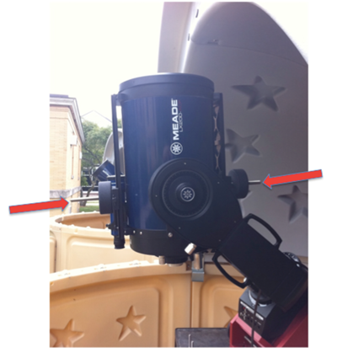Figure 1: Arrows show the two weights to screw on or off to correct for offsets of mass while pointing straight up.
   6. You want to balance it so that it stays in this position. You will do this by screwing on/off the weights pointed at by the arrows in Figure 1.
   7. Holding the telescope straight up, see what way the telescope wants to move and counteract with the counterweights.
   8. For example, if the telescope moves to the left in Figure 1, then first screw the left weight toward the telescope. When, screwed all the way in, screw out the weight on the right side until the telescope is balanced, i.e. when you let go of it, it stays pointing up.
   9. Next, move the telescope so that it is pointing horizontal (Figure 2).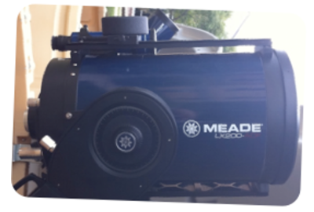Figure 2: What a horizontally pointing telescope looks like. Now, we have to move the entire weight assembly along the rail shown in this image running along the top of the telescope (and along the bottom). Be careful, they can fall off the rail so loosen carefully while moving these, while a teammate holds the telescope.
   10. Now, to balance in this direction, we need to move the entire weight assembly left or right to balance. Do not screw/unscrew the weight up or down since that will affect the balance of the vertical direction.
   11. Holding the telescope carefully in the horizontal direction, see which way the telescope moves.
   12. Unscrew (carefully) the weight assembly that moves left/right (horizontally) along the telescope tube. You can move either one, but it is best to move them together.
   13. For example, if the telescope moves mirror down (counter clockwise), then you will need to shift the two weight assemblies to the right to counter.
   14. Once you have the vertical and horizontal balanced, you should be able to move the telescope arbitrarily and when you let go, it should not move too much. If it moves fast, then you did not balance the telescope.
   15. Remember the better balanced, the better the telescope will track and the easier it is to use the telescope overall. It is worth your time to balance it.
9. Find a bright star in the sky and go to it, with the scope still powered off. Just manually move the telescope.
10. If the star needs to be focused in the telescope eyepiece, unlock the mirror. (Never focus with a tightened mirror!) After you are done focusing, tighten the mirror lock until you just feel a little pressure. If you need to focus again later, then unlock the mirror first. By locking the mirror, the telescope should stay in rough focus. If you ever feel resistance when focusing, stop and check the mirror lock. It is nice to lock the focus since when you move around the sky the focus will not change.
11. At this point, it is useful to verify that the finder scope is also aligned with the optical axis. In other words, find a star in the center of the eyepiece and make that star at the center of the finder scope's crosshairs. Use the 5 alignment screws on the finder scope to align. Remember not to force the screws, so sometimes you must loosen one side and tighten the other. This is tricky, but with a little playing around you will get it. It is worth the effort.
12. Make sure you know where Polaris is in the sky. Use Stellarium if necessary.
13. Align the telescope (Dec), so that it is 90 degrees to the wedge, which means that the telescope is pointed along the axis of the telescope mount. This should make it close to Polaris. Then, it should look something like Figure 3. It does not have to be perfect, but it should be as close as you can get it.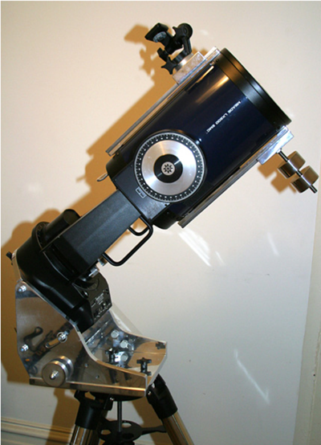Figure 3: What a 90 degree pointed telescope looks like. It does not have to be perfect, but from then on, it is the assumed 90 degree location for you and the software.
14. Align the RA so that the RA lock lever is pointed South (toward the corn field).
15. Although not necessary, I find it easier to align from behind the telescope on a stool, so rotate the eyepiece up.
16. Before we make any adjustments of the wedge azimuth and elevation, we need to **SLIGHTLY** loosen the bolts that hold on the wedge to the telescope. Remember the rules about loosening and tightening from Chapter 1.
    1. The main idea is to loosen the holding nuts-- at **max** ¼ to ½ a turn! They might be loose already, so check that too.
    2. The wedge adjustment bolts are: the 4 bolts on the azimuth (bottom plate, Figure 4 & 5) and the 2 bolts (1 on each side) on the elevation (Figure 6). See the images below. Only loosed the bolts indicated with the black arrows. You **must not** loosen the bolts pointed to with the Red arrows, as they are pivot points. If you do this wrong, the wedge and telescope can fall off!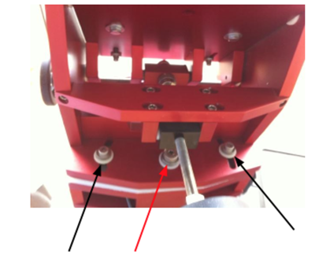Figure 4: The azimuth bolts on the back. The red arrow is the one you should not touch. The two black can be slightly loosened to move the wedge.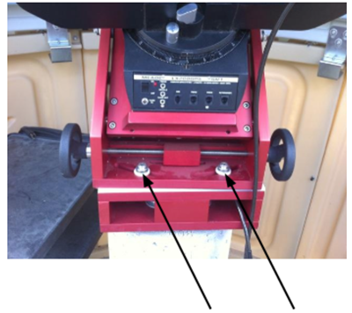Figure 5: The azimuth bolts on the front. The two black bolts can be slightly loosened to move the wedge. With the two bolts in the front and the two bolts in the back loosened, you can easily move the wedge in azimuth with the handwheels shown on the right or left.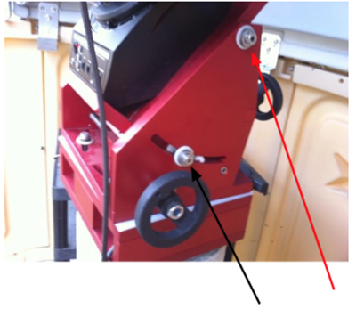Figure 6: The altitude bolts on the sides (both). The black bolt (one on each side) can be slightly loosened to move the wedge. With the two bolts loosened, you can easily move the wedge in altitude with the handwheel in the back (seen on the far right in the image).
17. With the main bolts loosened. We can use the wedge azimuth and wedge elevation controls in Figure 7 (light touches on the wedge movements go a long way) to align Polaris in the finder and eyepiece. Slowly.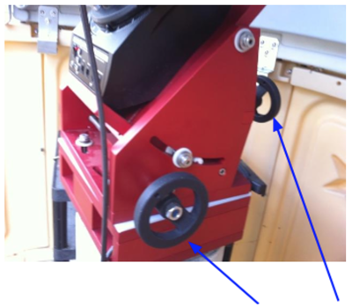Figure 7: You can see one of the azimuth wheels on the bottom, which moves the mount left and right, and the altitude wheel on the back, which moves the mount up and down. With a combination of these you can align the mount with Polaris.
18. If Polaris needs to be re-focused in the telescope eyepiece, unlock the mirror. (Never focus with a tightened mirror!) After you are done focusing, tighten the mirror lock until you just feel a little pressure. If you need to focus again later, then unlock the mirror first. By locking the mirror, the telescope should stay in rough focus. If you ever feel resistance when focusing, stop and check the mirror lock.
19. Now that you have Polaris centered in the eyepiece, the wedge azimuth is very close, so we likely don't need to touch it much from now on.
20. Now that the wedge azimuth pointing is nearly north, we can work on setting the telescope Dec to be truly perpendicular to the mount using Polaris.
21. Rotate the RA of the telescope, watching Polaris. Polaris should seem to rotate around a point. (If it's way off, you will have to use the finder scope to see the rotation.) We are aiming to get Polaris to rotate around the smallest circle we can (try to get inside the main eyepiece). Move the telescope Dec so that Polaris moves up or down in the field. Now, compensate this motion by moving the wedge elevation to get Polaris back in the center of the field. Rotate the RA of the telescope and see if the Polaris-circle is smaller or bigger. If larger, try the opposite direction. If smaller keep iterating until you get the smallest circle possible. Most groups can get the circle to stay in the eyepiece field for a full rotation of the telescope.
22. If the circle is offset, you can try zeroing in more with the wedge azimuth, but that will change the circle parameters, so be careful.
23. Now you should have Polaris centered and the telescope aligned on Polaris. You should never have to touch the wedge again. The telescope mount is mechanically aligned with Polaris! Congratulations! However, we are not done. We still have to align the system in software to the true North Pole and to the fact that you did not get the 90deg correct at the beginning, so the controller knows where to go.
24. Even with Polaris aligned, we have a small problem. Polaris is actually not at the North Celestial Pole. We have to fix our alignment to the actual pole. The Meade control system can help.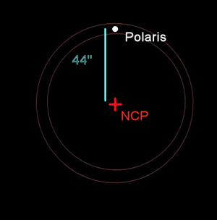Figure 8: Polaris is 44" away from the north celestrial pole.
25. Move the Telescope to the hour angle of zero. In other words, the RA lock handle is facing due North. Align with the HA circle on the telescope. Then, make sure the RA and Dec are locked.
26. Plug up the hand paddle, plug in the power supply, and turn on the drive.
27. After the drive boots up, push MODE to get to the top menus, then use the up and down arrows on the bottom of the paddle to access the SETUP menu. Press enter. Then select (using the same arrows) the ALIGN menu, press enter. Then, select one star and press enter.
28. The drive should give instructions for setting up the Polar Home. That's what we did when the drive was off, so just press ENTER.
29. Next, the telescope drive will move to where Polaris should be (if you were aligned to the NCP). This will move Polaris out of the field of view. Now using the wedge controls ONLY, move the wedge until the Polaris is now in the center of field again. This sets up the difference between the celestial pole and Polaris.
30. Now, we are really aligned with the Celestial North Pole. So, careful go back and tighten (but not crazy just until you feel a little resistance) all of the alignment bolts in Figures 4, 5, and 6. BUT make sure **not** to touch the wheels, or you have to re-align again.
31. Press ENTER.
32. Now, we have to calibrate the telescope drive offsets. This is due to your accuracy of setting the 90 deg location as well as the telescope being off from 90 deg itself. We will do this with some stars.
33. The telescope drive will attempt to find the best star to align on. (If the star is not acceptable due to the dome placement or whatever, just press the Down arrow button, and the drive will select another star.) Very likely you will not know the star. So, use Stellarium to be SURE that you have the know the right one. If you aren't sure, just press Down arrow button to find another.
34. Now, using ONLY the telescope paddle (the 4 directional arrows in the center), you will need to align the star to the center of the field. (To adjust the speed of the telescope, press the SPEED button, then 1-8 for different speeds.) Sometimes it moves so slow you can't tell it is moving.
35. Again, you **must** be 100% sure that the star it is asking for is the star you are aligning. If not, the entire calibration will be wrong. So, verify the star using Stellarium or something. You can use the finder scope to get close, then the eyepiece to finalize. Press ENTER when the star is centered. The telescope will say alignment successful.
36. To verify alignment go to another bright star. There are many ways to do this: MENU- OBJECT- STAR - NAMED, then scroll (using the bottom up and down arrows on the paddle) to the star you want. Press ENTER, then GOTO. Let the telescope slew, it will do a coarse slew then a fine slew, then it will beep. The alignment will never be perfect, but you should not be more than a little off.
37. Now observe a few objects for Lab 1.
38. If you do a goto on an object it will ideally be in the field of view or at worst a little off.
39. If you have to move more than 20 degrees or so (two fists at arm's length), it is best to bootstrap your way around the sky. To do that, you go from bright star to bright star until you hit your target. This is especially true for dim sources.
40. As you move around, if the stars are not centered, then you hold down the ENTER button for a few seconds, then release. It will ask you to sync, that re-calculates the alignment parameters.
41. If that procedure does not work, then you are not aligned.
42. Observe all you want. Now you are done.
43. You can either choose to park the telescope or just turn off the drive. In this class most people will just turn off the drive. If you are the next group to use it, you can also park which will save time later.
44. If you park the telescope, it will be faster next time. On your paddle do UTILITIES-PARK.
45. The telescope will move to the PARK position, then request you to turn off the drive.
46. When you start the telescope next time, it is ready to go, unless someone messed with it. See Chapter 3 for how to begin observing with an aligned telescope.